SwitchVI 48 Summary 20 September 2005

We collected 49 subs (subject nr 37 accidentally duplicated) in 6 groups (~ 8 in each). This is ellipses experiment when color of the ellipse can be black or white determining key switch/different category.

To remind:
There were 2 category structures (CJ and II) and 3 conditions:
2catCont - color is irrelevant, there are two categories
2catSwitch - color is relevant, there are 2 categories, black ellipses has exactly opposite category than white ellipses
4cat - color is relevant, there are 4 categories, black ellipses have different cat names than white ellipses

Accuracy analyses:

Summary: 4categories are easy for CJ but difficult for II.
This is oposite from what would be expected from 2 OR 4 CAT experiment done in our lab and published earlier.
Depends. Here pairs of categories are identical on two dimensions except for color. In the other paper pairs of categories were the same on one dimension but not on the other.

This is a random thought but these data almost suggest that the color is not represented very well in IT or caudate. Is there any validity or support for that statement? What if the third dimension was position (left of screen vs. right of screen) would we now get good ii4 cat learning? In other words would we get the pattern in ii that we got in cj?

No surprise that 2 cat switch is horrible for ii especially if color is poorly represented.
Not so expected that cj switch would be so bad. Is there a bimodality here? This is almost like a three dimensional disjunctive rule. Makes sense that would be hard.

One-way anova shows significant differences among groups (all blocks, also RT).
3-way mixed anova (5 block x 2 cat str x 3 condition):
Sig:
Block p<.001
Condition p=.001 (switch is difficult)
Block*condition p=.001
Block*catStr p=.044 (learning in CJ, little learning in II)
NS:
CatStr p=.447
Condition*catStr p=.355
If you just did this for the 2cat control vs 4 cat I’ll bet the interaction is significant whereas it would not be for 2 cat control vs. 2 cat switch.

Condition*CatStr is NS, but interesting (first chart overall acc, second last block):
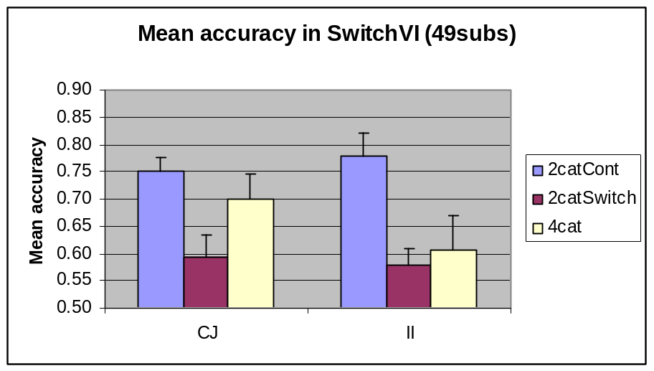
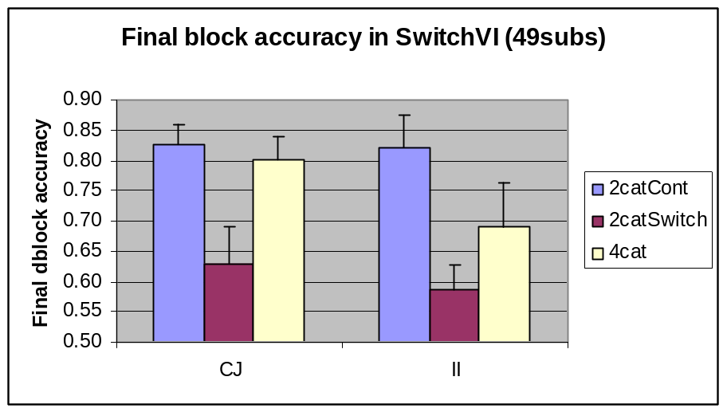

The difference is that for CJ, 4cat=control, both are better than switch. For II, control is better than both switch and 4cat, latter two equal at the beginning, 4cat getting better with training.

Details under the line, may be skipped:

Since ANOVA did not show the CatStr * Condition interaction, I looked at two things that may show the effect in a different way:

1. Effect of condition for each cat str separately:

One-way ANOVA significant or marginal in all cases.
CJ
Post-hoc for overall accuracy shows control > switch.
Post-hoc for last block shows control=4cat > switch.
II
Post-hoc for overall shows control > swich=4cat.
Post-hoc for last block shows control > switch.

T-tests:
CJ
Control > switch (all blocks)
Control = 4cat (except block1 p=.073)
4cat > switch (block3 and 5, overall p=.1 since block1 p=.7)

II
Control > Switch (all blocks)
Control > 4cat (block1 & overall, marginal block3)
4cat = switch (except block 1 p=.053 switch>4cat understandably)

2. Effect of category structure for each condition separately
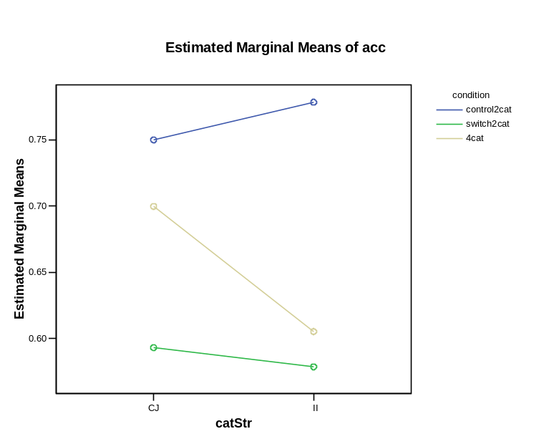
T-tests:

Control: CJ=II (p>.5)
Switch: CJ=II (p>.7)
4cat: NS, but tendency for CJ>II (p=.25)

This is playing with data: Confusion of white and black ellipses – tendency to categorize one color better than another.

To explore the qualitative differences in performance, I created a “preference” measure. It is the aboslute value of the difference between overall performance and perfomance on one color of ellipses. Can be also understood as partitioning of knowledge in case of the control group. Results are interesting but NS.
